Date: 4/24/2023

To: Fann, OCWD, USDA

Re: Arsenic Weekly Progress Updates

Cc:

Sender: Jan Tijmes, EIT, Ardurra
________________________________________________________________

Acquisition of Treatment Tanks
Canyon State Filtration received the 4 treatment tanks; (2) for wellsites 2& 3 and (2) for wellsite 4. Valves arrived on Friday, Apr 21. Spools are set to ship out early week of April 24th. If product is received by end of week, then next week (week of May 1) the treatment tank system can be reassembled at the Canyon State offices. Then the following week (week of May 8) they can be reassembled at the wellsites.

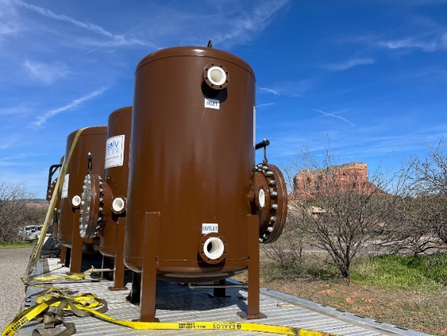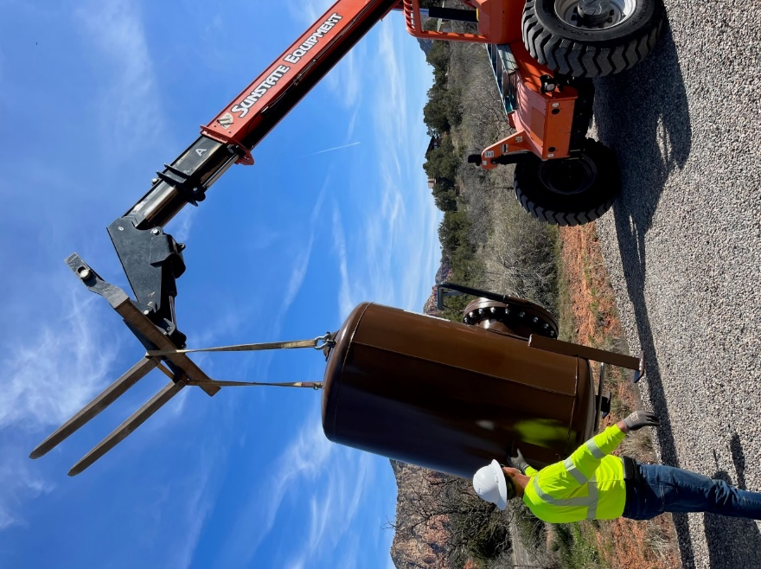

Exterior Tank Painting at Panorama
Prep and final painting took place April 17 thru April 24. Tanks have been painted a semi-gloss green urethane coat to last approximately 15 years. All components painted with same paint. Industrial Inspections conducted 2 field investigation reports for exterior prep and final painting. STS Tank has completed their subcontractor duties for the Arsenic Project.
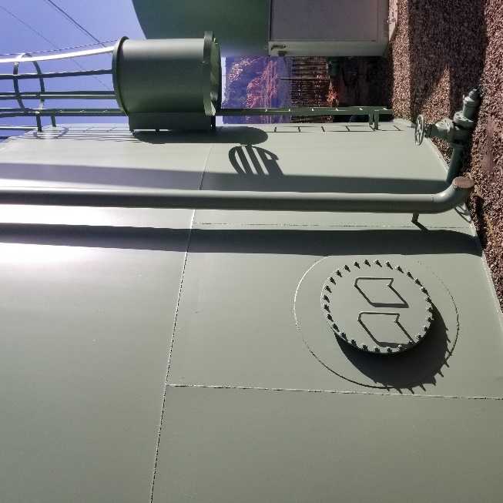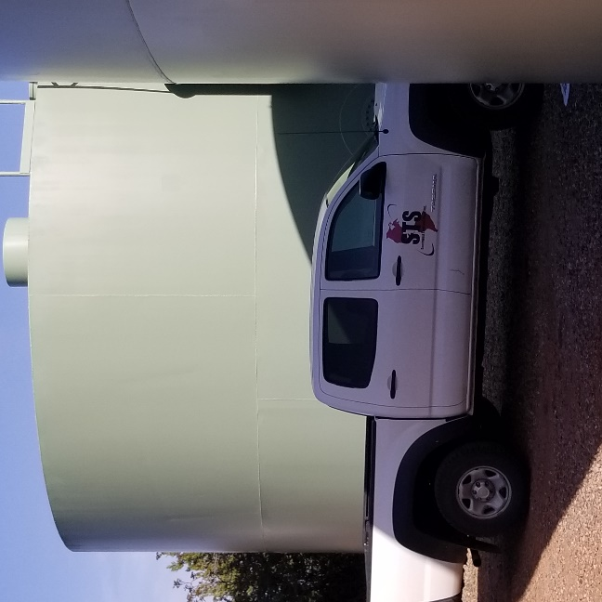

Fann PayApp 6
Fann submitted a new Pay App for materials. Items include the pressure vessels (treatment tanks), 50% of the 4” C-900 and DIP pipe, bends, and appurtenances (valves, mixers, yard hydrants), and 50% of the 6” C-900 and DIP pipe, bends, and appurtenances (valves, mixers, yard hydrants). Pay App will be reviewed this week and discussed at the monthly progress meeting.

Waterline Project Updates:
Since the previous progress update on 3/23/2023, OCWD had its Bid Opening. After 6 addenda, the Bid Opening date was held on Friday, March 31, 2023 at 2pm. The bid attracted 7 plan-holders, 2 formal bids, and 1 late bid. A series of post-bid meetings have been held with USDA to review if the project can be further innovated to reduce the cost/LF of waterline installation. Research was done to review typical installation costs across Arizona. Discussions were held with local and nearby contractors about innovative ways to install the system. Currently, both CIPP and semi-structural polymeric pipe rehabilitation is being explored. A follow-up meeting with USDA will be held on April 28th following our Arsenic progress meeting. Both Mainlining America and IronTree Construction have been helping Ardurra estimate installation with these technologies.

Next Meetings:
Next Progress Meeting: April 28, 10am
Waterline Post-Bid Follow-up Meeting: after Progress Meeting for USDA, Ardurra, and Oak Creek Water

