Date: 6/9/2023

To: OCWD, USDA, FANN, SWI

Re:

Cc:

Sender: Jan Tijmes
________________________________________________________________

6/5/2023: FANN
As of Friday June 2, Canyon State had most of the arsenic installation completed at Well 4, and Fann was potholing the site to locate existing utilities.

Canyon State aims to deliver and install at well 2/3 this week- don’t know his exact schedule of what days he will be at the site vs working in his yard.

There are two guys from FANN working on the Well 4 site all week, Jim Bennet is the Supervisor on site.

6/6/2023: USDA
Michael Dean provided new loan amount terms to Doug Bowen, OCWD. The OCWD Board met publicly on 6/5 to discuss terms. A new total loan/ grant amount was agreed upon. OCWD rate study accountant will request a rate increase in each of the next three years.

6/7/2023: FANN
Visited wellsite 4 with Art Beckwith to meet Bim, Jim and Patrick (Fann). Question arose regarding tying into the distribution system. Without ADEQ’s AOC, the new construction will have to remain offline until approval. Decision was made to add a gate valve to the treated water line, so the arsenic system can act as a separate system and remain offline while the new well line to the distribution line (approx. 45’ of distribution pipe) can be treated as a tie-in/ replacement. The arsenic system will remain offline until it is tested and permitted while the new distribution line will be disinfected and tied into the system to keep well 4 supplying water to the network.

6/8/2023: FANN
Visited site to review progress with Jim and Patrick. Trenching near arsenic tanks and electric panel has begun. Crew will install one length of pipe from the inlet and outlet connection to the arsenic treatment system before returning to installation of the tie-in line from the well head to the distribution line. The arsenic vessels at Wellsite 4 still require tightening down as well as a few pipe lengths added to the system.

CANYON STATE:
Wellsite 2&3 vessels and pipe should be loaded onto a trailer by Fri 6/9 and delivered to site Monday 6/12.

6/9/2023: FANN
One pipe length with approx. 3.5ft of cover was added to the inlets and outlets of the arsenic treatment tanks. Next, Fann will excavate the pipe from the pitless adapter to the tie-in point to install new pipe and appurtenances.
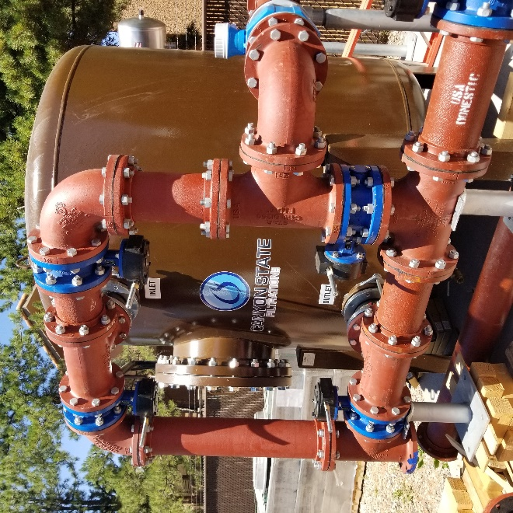
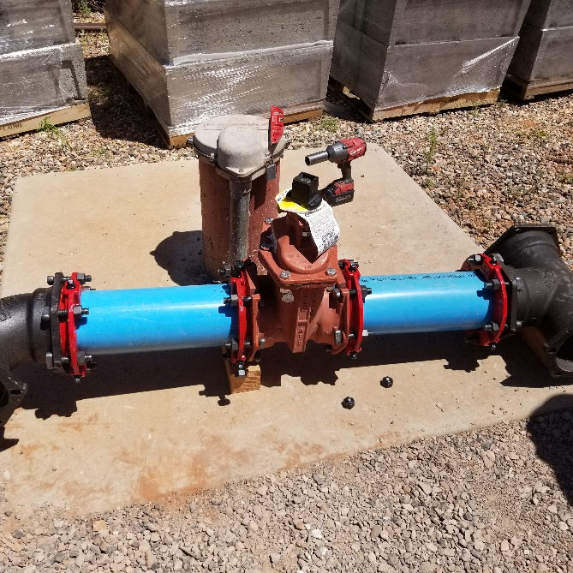
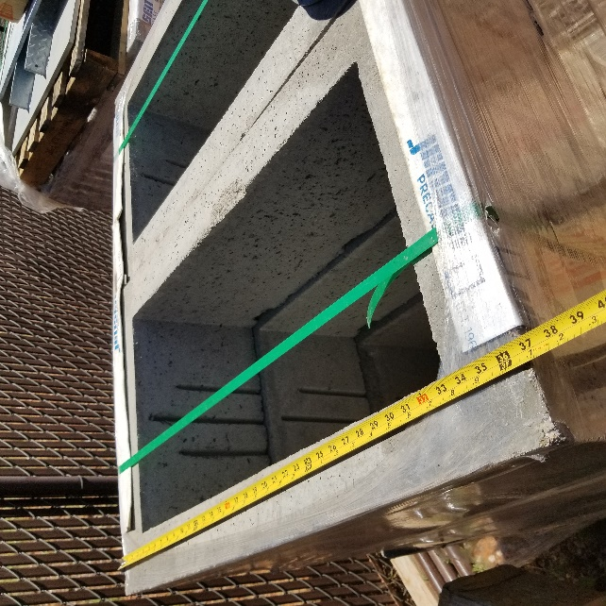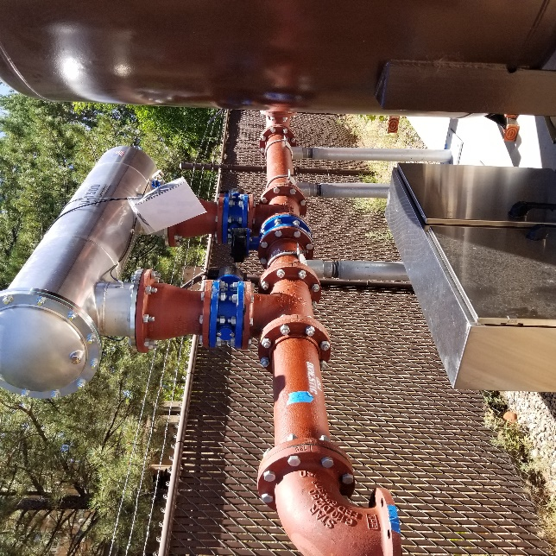
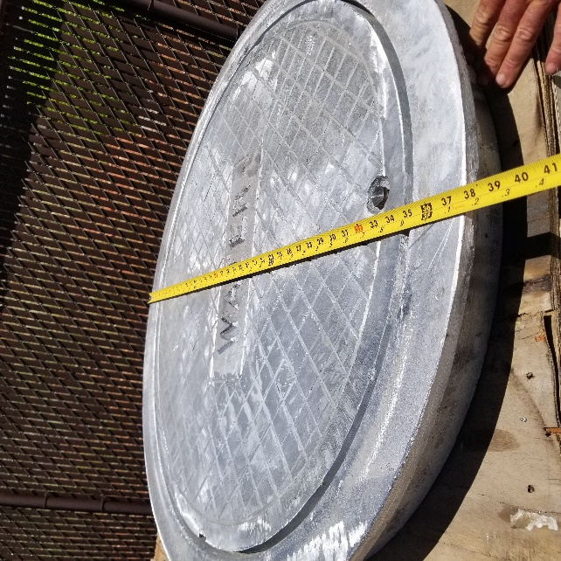
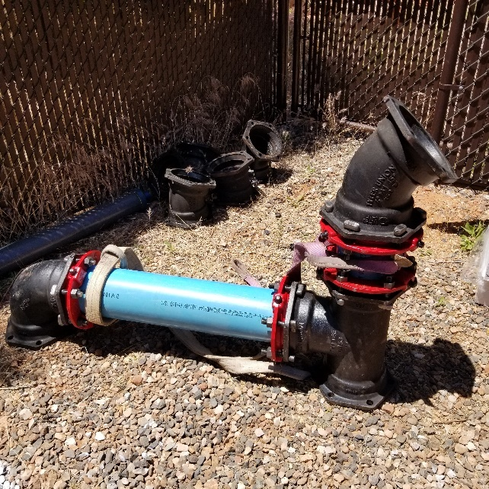

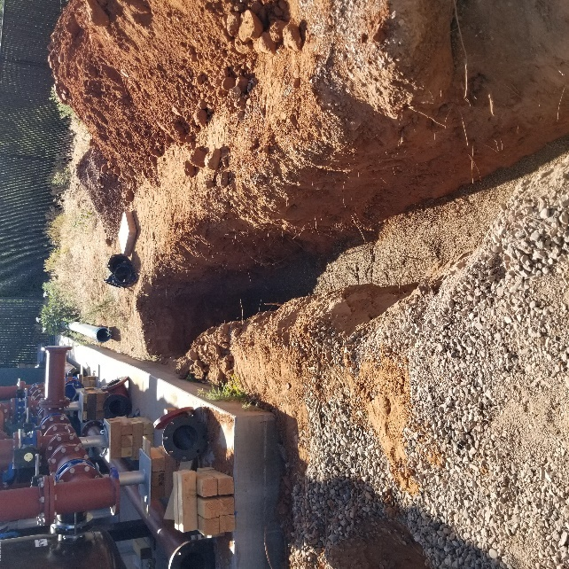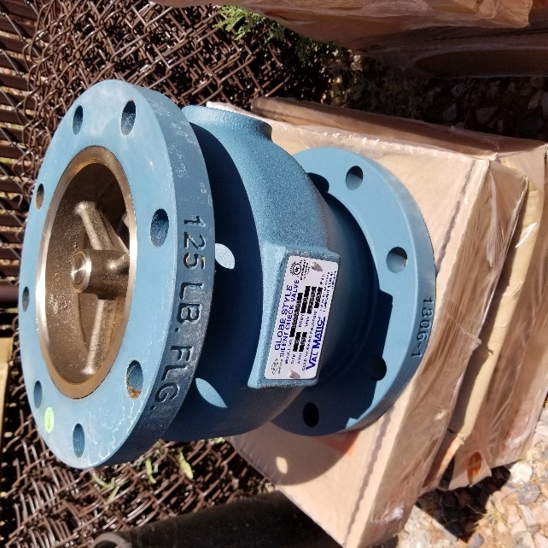

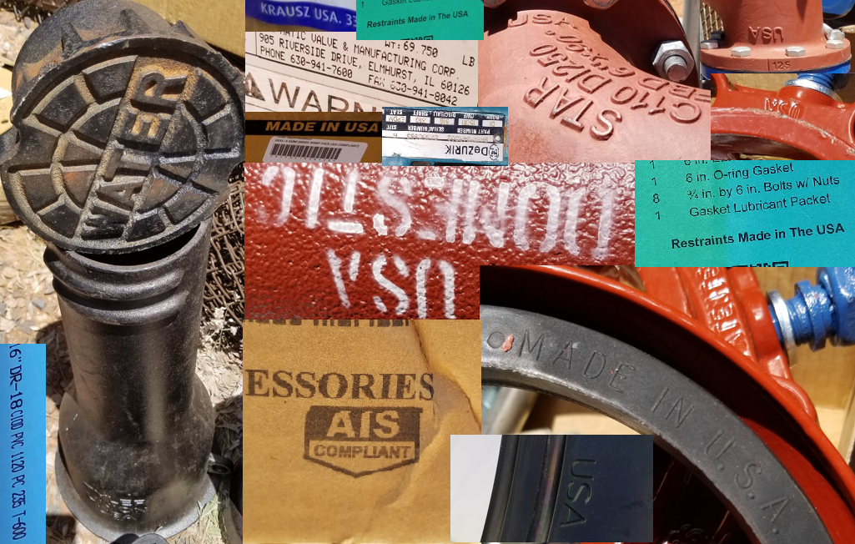

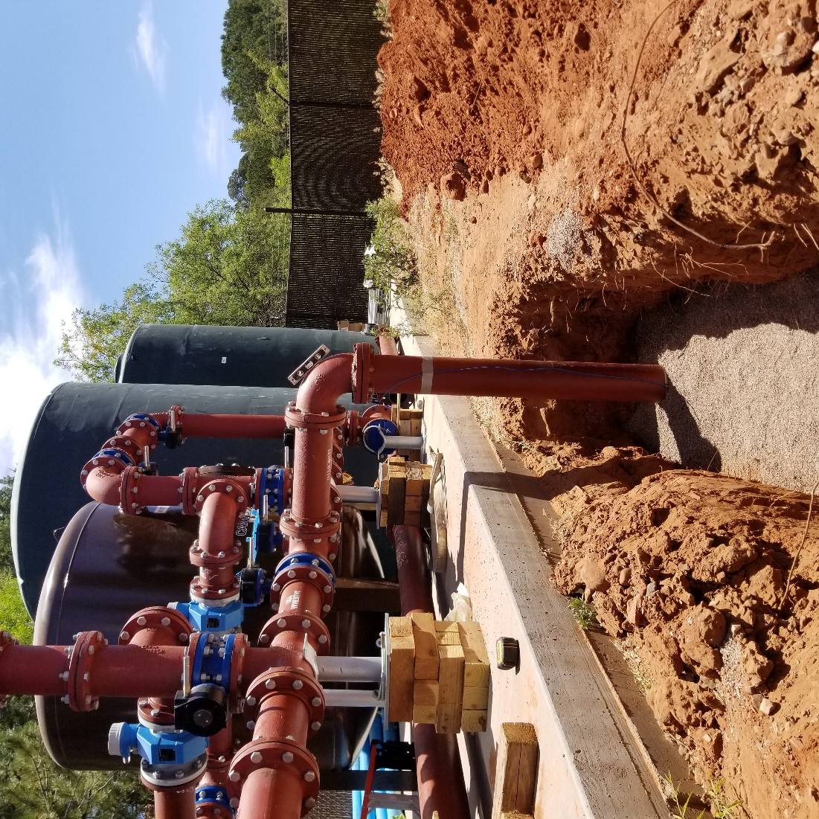
6” DIP into trench with 6” C-900. 6” shade below pipe with 12” cover shade. Shade material is a washed bedding sand, aka: angular chip, tree sand, 1/8”minus.

